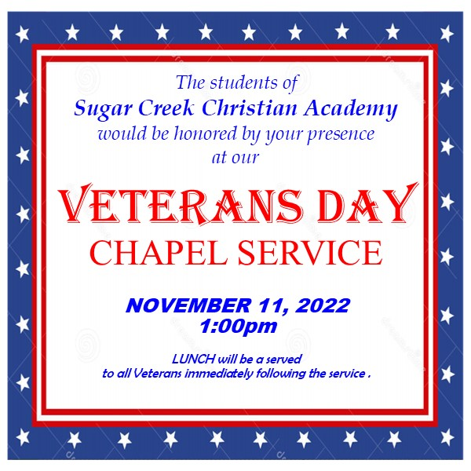
UPCOMING EVENTS
-NOV. 1-4
BRIGHTWHEEL TRAINING
-NOV. 11
VETERANS DAY SERVICE
-NOV. 22
THANKSGIVING CHAPEL
PARENT-TEACHER CONFERENCES
-NOV. 23
REMOTE LEARNING DAY
-NOV. 24-25
NO SCHOOL
-NOV. 28
REMOTE LEARNING DAY
SCCA is growing and will transitioning to the BRIGHTWHEEL application for all tuition payment plans beginning on January 1, 2023. After this date, a processing fee of $25 will be charged to families who pay cash, check, or card outside of the Brightwheel Application. If you have not signed up to make payments through Brightwheel please do so as soon as possible. Pastor Mike will conduct training seminars on November 1st through November 4th daily from 8:30-9:00am and again from 3:15-3:45pm. If you have not signed up for Brightwheel payment we asked that you attend one of these meetings. These meetings will also be a good time to address any questions you might have.
NOV. 23 REMOTE LEARNING DAY
NOV. 24-25 THANKSGIVING BREAK
NOV. 28 REMOTE LEARNING DAY
NOV. 22ND

